**IMPORT DISORDER/DISORGANIZED EXCEL FILE INTO DATABASE IN CORRECET ORDER USING PHP, HTML & SQL:**

**PHPFILE : UPLOAD EXCEL FILE :**

**index.php :**

<!DOCTYPE html>  
<html lang="en">  
    <head>  
        <meta charset="utf-8">  
        <meta name="author" content="mahesh_kumar">  
        <title>Simple page</title>  
    </head>  
<body>  
      
    <form  action="http://localhost/uploadExcel.php" method="POST"  
           enctype="multipart/form-data">  
   
               <input type="file"  name="file" >  
    
               <input type= "submit" name ="Upload" >  
    
    </form>  
      
</body>  
</html>

**PHP FILE : INSERTING EXCEL DATA TO DATABASE:**

**uploadExcel.php**

<!DOCTYPE html>  
<html lang="en">  
    <head>  
        <meta charset="utf-8">  
        <meta name="author" content="mahesh_kumar">  
        <title>Simple page</title>  
    </head>  
<body>  
      
    <?php   
    **define**("DB_SERVER", "localhost");  
    **define**("DB_USERNAME", "root");  
    **define**("DB_PASSWORD", "root");  
    **define**("DB_DATABASE", "demo_data");  
      
    $conn = **mysqli_connect**(DB_SERVER, DB_USERNAME, DB_PASSWORD, DB_DATABASE);  
      
     **if** (!$conn) {  
    **die**("Connection failed: " . **mysqli_connect_error**());  
    }   
    **else**{  
                      echo "Database connected <br>";  
    }  
    $fileName = $_FILES['file']['name'];  
    $fileTmpName = $_FILES['file']['tmp_name'];  
    $handle = **fopen**($fileTmpName, 'r');  
    $count=1;  
    **while**(($filesop = **fgetcsv**($handle, 1000, ',')) !== **false**)  
   {  
    **if**($count==1)  
   {  
     **for** ($i = 0; $i < 4; $i++)   
     {  
       
       **if**($filesop[$i]=='name')  
       {        $name = $filesop[$i];   
                 $a=$i;         }  
        **if**($filesop[$i]=='email')  
       {     $email =  $filesop[$i];  
              $b=$i;           }  
       **if**($filesop[$i]=='phone')  
       {      $phone= $filesop[$i];   
              $c=$i;           }   
       **if**($filesop[$i]=='city')  
       {      $city=  $filesop[$i];  
              $d=$i;          }  
      }  
      $count++;  
     }  
     **else**{  
     $name = $filesop[$a];  
     $email = $filesop[$b];  
     $phone= $filesop[$c];  
     $city= $filesop[$d];  
     $run =**mysqli_query**($conn,"INSERT INTO excel_data (name,email,phone,city) VALUES ('$name','$email','$phone','$city')");   
  }  
  }  
  
   **if**($run){  
     echo "<script type=\"text/javascript\">   alert(\"You database has imported successfully\");    </script>";  
   }  
   **else**{  
   echo "<script type=\"text/javascript\">   alert(\"There is a problem\");    </script>";  
   }  
?>  
</body>  
</html>

**Output of task: Choose file to upload:**

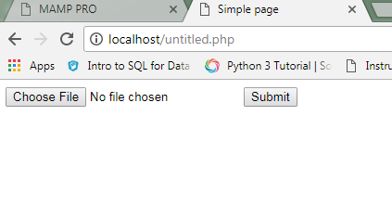

**File chosen to upload:**

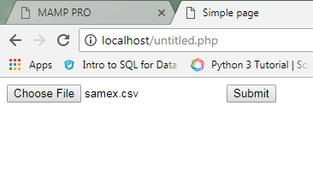

**excel file has imported successfully:**

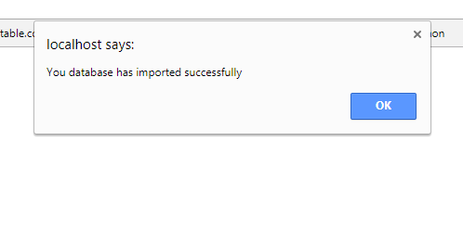

**Proper ordered excel file:**

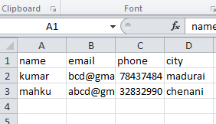

**Non proper ordered excel file:**

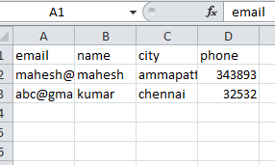

**Proper ordered &non proper ordered excel file has updated into databese**

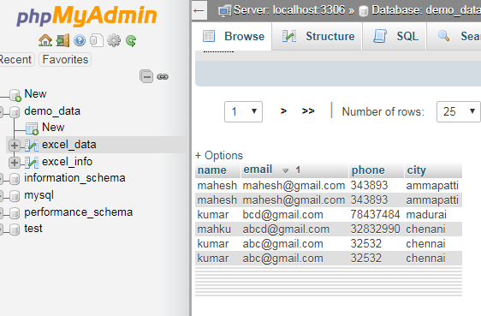

**Uploaded file in excel format:**

